St. Margaret’s English Community – RCIA

Christian Destiny: The Four Last Things

Some years ago, there was a peaked interest in the concept of “destiny” sparked by the novel Left Behind and then the video series Rapture, or one of Steven Spielberg’s forays into science fiction, the series entitled Taken, which riveted my own attention for weeks as I made my way through the 5 volumes of video stories.

In a more serious and current vein, surrounded as we are for the last year by a mysterious virus that has morphed into a pandemic and affected millions, causing hundreds of thousands of deaths and upsetting the life of nearly every person, and with an increase in suicides and deaths, we find ourselves facing questions about our own mortality.

Forced as we have been perhaps more than ever before to face such weighty questions, each culture, every nation and all peoples are confronted with the question: What happens after death? Is this all there is to life?

This Is Our Faith, Chapter 11, “Christian Destiny: The Last Things” pp.147-161.

People throughout the world have mixed feelings and outlooks about death.

On one hand, we are willing to spend a lot of money trying to hold off the moment of death, prolonging our life, taking care through diet, exercise, beauty products, life-enhancing vitamin supplements, optional surgeries etc… to hold off the inevitable.

We add multiple safety features to cars and in our homes in the hope of staving off death for a few more years. At the same time, we have a dark fascination to films television programs that deal with death and dying, especially when it is violent and it’s about someone else’s death. How many have witnessed a tragic traffic accident – and noted everyone slows down to “look”! Or hearing of a suicide, rush to the scene to see “who” it is?

Truthfully, most of us never want to think about death and questions about what happens after it. Up until this year, we could really avoid it unless someone dear and dear to us passed away. But sometimes we have to face our own morality through a serious accident or sudden illness, and at such times the thought that runs through most people’s minds is, “What will happen to me when I die?”

Our textbook opens this chapter on Christian Destiny with a story from the 7th century about a monk named Paulinus who visited King Edwin in the northern part of England with the hope of converting the king to Christianity. The story tells of an elderly court official interrupting Paulinus’ preaching with the question, “Butt what happens after death? The life of man is like a little bird flying through this lighted hall, drawn in at one door from the darkness outside, then fluttering through the warmth and light inside, and inevitably passing through a window or doorway on the opposite end into the dark unknown beyond. CAN YOUR NEW RELIGION SOLVE THIS MYSTERY FOR US? What will happen to us after death, in the dark, dim unknown?”

This is indeed a serious question.

For Christians – and for Paulinus the monk – however, the answer is quite simple and can be summed up in a 3-word phrase that is applied to all of the four Gospels: “JESUS IS RISEN!” Everything else we read in the Scriptures is more or less a way of filling out the details of this simple phrase. “JESUS IS RISEN!” This is the essential part, the core of the kerygma or message of all preaching. As St. Paul reminds us, “If Christ has not been raised, then empty [too] is our preaching; empty, too, is your faith… If Christ has not been raised, your faith is in vain; you are still in your sins. Then those who have fallen asleep in Christ have perished. If for this life only we have hoped in Christ, we are the most pitiable people of all” (1 Cor. 15: 14, 17-19).

Christ’s Resurrection is the work of the Holy Trinity. God the FATHER “raised up” Christ the SON and by doing so introduced the humanity of Jesus into the relationship of the Holy Trinity. The Resurrectio9n has many implications for us, including bringing us into a deeper and more personal relationship with Christ as his brothers and sisters through Baptism. Christ’s Resurrection and its accompanying grace make this possible.

Returning to the story from our text about Paulinus the monk and his questioner, the story opens us to understand that for Christians, while death is inevitable, it is not “the end.” Or as another saintly monk wrote a few centuries later, “Death does not have the last word. Life does!” [St. Bernard of Clairvaux]. “Death is the gate of life.” Or as Jesus himself taught us in the Gospel of St. John, “I am the resurrection. Anyone who believes in me, even though that person dies, will live, and whoever lives and believes in me will never die” (John 11:25-26).

For nearly every human being, facing our own death, our mortality isn’t easy. It can be sobering and for many even frightening as we face the big UNKNOWN. Some people are thrown into despair and even depression thinking about – faced with – death especially through a critical illness. Our Christian faith and Catholic outlook provide us with answers to the questions of death – as do most religions. But more, we have a different outlook and advantage because the person who supplied those answers has actually died and risen again! Believing in Jesus’ promise that we too shall rise to new life does not take away completely the sting of death, but our faith can help us understand that death is not a final ending but a new and glorious BEGINNING.

The Four Last Things: Death, Judgment, Heaven, Hell

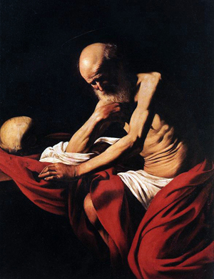
JEROME IN MEDITATION BY CARAVAGGIO
As Catholics, we believe and affirm that we are pilgrims on Earth, journeying to our true home in Heaven. Each of us has a beginning (conceived by our parents) and each of us will have an end. What we will experience and attain as we arrive at this end is the subject of this series. This is our DESTINY.
We do not hear much these days about the topic of the Four Last Things and that fact is detrimental to our spiritual life. It is imperative that we spend time frequently pondering, in prayerful meditation, these things that will come to visit each of us. Catholic teaching identifies the Four Last Things as:
- Death
- Judgment
- Heaven
- Hell
Each of us will arrive at the time when this earthly life will end – that is what we call death. You will then come face to face with your God to be judged and learn if you will spend eternity in Heaven or Hell.
“Just as it is appointed that human beings die once, and after this the judgment, so also Christ, offered once to take away the sins of many, will appear a second time, not to take away sin but to bring salvation to those who eagerly await him” (Hebrews 9:27-28).
The first part of this DESTINY then is DEATH.
So, the first thing that happens to each of us at the end of our earthly life is death. Let’s talk a bit about that. Where does death come from? Death is a result of sin.
“Therefore, just as through one person sin entered the world, and through sin, death, and thus death came to all, inasmuch as all sinned…” (Romans 5:12).
To fully understand this, we need to go back to the beginning of Creation and to the story of Creation in the opening chapters of the Book of Genesis. Before the Fall of Man, man possessed Sanctifying Grace. By Sanctifying Grace, God made Adam and Eve partakers in the Divine Life. They were in communion with God. We
In addition to Sanctifying Grace, God also bestowed upon Adam and Eve what are called Preternatural Gifts:
- Infused knowledge
- Integrity
- Bodily Immortality
Although we are concerned primarily with bodily immortality, let’s look at each gift.
Infused Knowledge
The infused knowledge given to us by God differs from knowledge we acquire by study and experience. God, Himself, placed certain knowledge within us about:
- God and all of His attributes,
- Our relation to God and the moral law
- The physical universe, its material and spiritual nature and its purpose
This knowledge provided an understanding of why we exist; that is, what we were made for (our supernatural end) – we were made for God and Heaven.
Integrity
Adam and Eve lived without an inclination to sin. The gift of integrity meant that their human passions and appetites did not overcome their human reason and will. They lived in a type of balance or integration that made it possible for them to avoid sin.
Bodily Immortality
Older Catholics who were taught through the use of a Catechism of questions and answers will remember this question: “Why did God make you?” The answer given to this profound question is very simple: “God made me to know Him, to love Him, and to serve Him in this world, and to be happy with Him forever in the next.”
Out of His infinite goodness, God made us in His image and likeness in so that we might share in His happiness and beatitude, in communion with Him, for all eternity in Heaven. What is important to see here is that Adam and Eve, like we are, were pilgrims on this Earth. The Garden of Eden, what we at times refer to as Paradise, was not Heaven. At some point, they were to pass on to the next life in Heaven, but it would not have been through what we call death.
But all of this changed when Adam and Eve sinned. The Fall of Man cost them Sanctifying Grace and the three Preternatural Gifts – they lost them utterly and entirely. And since they no longer possessed them, they could no longer pass them on to us through generation. They forfeited not only their possessions, but also our inheritance.
One of these gifts that were lost was bodily immortality – Adam and Eve, and thus each of us, would now face bodily death. This is how death came to us:
“The Lord God gave man this order: ‘You are free to eat from any of the trees of the garden except the tree of knowledge of good and bad. From that tree you shall not eat; the moment you eat from it you are surely doomed to die’” (Genesis 2:16-17).
Bodily Death Defined
So we now move on to define bodily death – Death is nothing more than the separation of a person’s human body and human soul. We do not cease to exist at death. We do not become unaware of things at death. The Church does not believe in “soul sleep” as do some non-Catholic Christians. Our body ceases to live as a result of age, sickness or accident, but we will perdure. Life will go on; our souls will continue to be alive, but apart, for a time, from our bodies which will no longer be animated.
With the loss of bodily immortality also comes suffering and illness. So it is now our part in this life to suffer and die.

The second part of this DESTINY then is JUDGMENT.
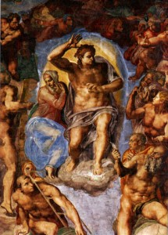
THE LAST JUDGMENT (DETAIL) BY MICHELANGELO

The Particular and Universal Judgments
“And just as it is appointed for men to die once, and after that comes judgment…” (Hebrews 9:27).
Bodily immortality, one of the preternatural gifts God gave to humankind, was lost when Adam and Eve sinned. The result is that men and women die at the end of their earthly lives. But, Jesus Christ conquered death so bodily death is no longer a permanent condition.
Prior to Redemption, there was no possibility for the dead to enter Heaven, but now there is. Christ defeated sin and death and has opened the gates of Heaven to us.
During our earthly lives, we have time and opportunity to accept God’s free gift of salvation and gain merit. We have the opportunity to enter into a communion with God and become holy. It is an opportunity for us to turn from sin and to live and love as God does, sharing in His Divine Life through Grace. This conversion from sin to God, this leaving behind the darkness to live in the Light, is a life-long pursuit. That is why Scripture speaks of salvation as a past event, a present happening and a future hope.
When we die, that is, when the soul separates from the body, we face judgment. The time for choosing good or evil ends at death. The time for meriting reward ends at death. Then is the time for judgment.
“For we must all appear before the judgment seat of Christ, so that each one may receive good or evil, according to what he has done in the body” (2 Corinthians 5:10).
There is a tendency today to discount sin – to either deny its reality or to ignore its consequences. But, just as we have seen and know that death is real, so can we see and know the reality of sin and is consequences. Simply look at your own life; only one who has deluded himself would deny the stark reality that faces us in a world separated from God.
“But God said to him, ‘Fool! This night your soul is required of you; and the things you have prepared, whose will they be?’ So is he who lays up treasure for himself, and is not rich toward God” (Luke 12:20-21).
So let’s examine judgment.
Particular Judgment
When we die, we shall face two judgments. The first of these is what theologians call the Particular Judgment. There will come a time when we are individually judged by Christ. That moment will occur immediately following our death in the ordinary events of human history or, for those still alive, at the Second Coming of Christ. We will see our lives as they were, every act of sin and its consequences and every act of goodness and its consequences (see again Matthew 25: 31-460. We will see ourselves as God sees us. And, we will learn whether our reward is the beatitude and glory of God in Heaven or the everlasting punishment of Hell, separated from God.
This is the Particular Judgment.
For those who die before the return of Christ, our souls will depart for either Hell or to Heaven to await the Universal Judgment and the General Resurrection of our bodies at the Second Coming of Christ. These saved who depart for Heaven, if they are not perfected in the earthly life, will first undergo purification and suffer temporal punishment in Purgatory.
The saved who experience their Particular Judgment at the Second Coming of Christ will not have need of Purgatory as we ordinarily view it because they will already have undergone their final purification. Although Purgatory is not one of the Four Last Things, we will look deeper into it when we examine Heaven and Hell in the next installment.

The Universal Judgment
At the end of time, when Christ returns, all the sins of each person will be revealed for all to know. Theologians call this the Universal Judgment. Some refer to this as the final or general judgment.
It seems at times we are more concerned about what others know about us than what God knows. We act as if we are more embarrassed by others knowing our faults than about God knowing them. Contemplating the Universal Judgment is one of those times. Out of embarrassment, we might wonder why there should be a Universal Judgment.
“When the Son of man comes in his glory, and all the angels with him, then he will sit on his glorious throne. Before him will be gathered all the nations, and he will separate them one from another as a shepherd separates the sheep from the goats, and he will place the sheep at his right hand, but the goats at the left. Then the King will say to those at his right hand, ‘Come, O blessed of my Father, inherit the kingdom prepared for you from the foundation of the world…’” (Matthew 25:31-34).
The justice of God demands that all be revealed. How often in this life does it appear that the good suffer and the wicked prosper? We see this and know that this cannot be right. At the Universal Judgment, we will know that everything is as it should be. God’s justice and His mercy will prevail.
In this life, we cannot see into the hearts of others, but God can and does. Jesus told us not to judge others. In part, this is why. We can and should judge their actions, but we can never know their hearts… until the Universal Judgment when all will be revealed and each person’s final choice is revealed.
Does the prospect of the Universal Judgment disturb you? One of the things for which we have time to overcome in this life is the sin of pride. It is because of pride that we fear others knowing our inmost dark secrets. The practice of humility, strengthened with frequent sacramental confession can overcome that fear and deepen our spiritual life.
So that’s it… “it is appointed for men to die once, and after that comes judgment…

The third part of this DESTINY then is HEAVEN.
Popular, secular opinion seems to conclude either: 1) there is no after-life or 2) everyone and their pets go to heaven. There isn’t much talk about Hell, except to dismiss the possibility of anyone going there.
But one historical figure spoke very forcefully about the reality of Hell and the very real possibility of human beings spending eternity there. That person is none other than Jesus Christ, the Second Person of the Blessed Trinity who became man. God did not dismiss Hell as either non-existent or not a threat. We should follow His example and learn what He taught.
“Therefore, stay awake! For you do not know on which day your Lord will come. Be sure of this: if the master of the house had known the hour of night when the thief was coming, he would have stayed awake and not let his house be broken into. So too, you also must be prepared, for at an hour you do not expect, the Son of Man will come” (Matthew 24:42-44).
Jesus exhorted us to be ready for judgment. Why? Why does it matter? If Hell does not exist or if there is no after-life, what possible difference does being ready make? Jesus provides us the answer:
“When the Son of Man comes in his glory, and all the angels with him, he will sit upon his glorious throne, and all the nations will be assembled before him. And he will separate them one from another, as a shepherd separates the sheep from the goats. He will place the sheep on his right and the goats on his left.
“Then the king will say to those on his right, ‘Come, you who are blessed by my Father. Inherit the kingdom prepared for you from the foundation of the world. For I was hungry and you gave me food, I was thirsty and you gave me drink, a stranger and you welcomed me, naked and you clothed me, ill and you cared for me, in prison and you visited me.’
“Then the righteous will answer him and say, ‘Lord, when did we see you hungry and feed you, or thirsty and give you drink? 38 When did we see you a stranger and welcome you, or naked and clothe you? 39 When did we see you ill or in prison, and visit you?’
“And the king will say to them in reply, ‘Amen, I say to you, whatever you did for one of these least brothers of mine, you did for me.’
“Then he will say to those on his left, ‘Depart from me, you accursed, into the eternal fire prepared for the devil and his angels. For I was hungry and you gave me no food, I was thirsty and you gave me no drink, a stranger and you gave me no welcome, naked and you gave me no clothing, ill and in prison, and you did not care for me.’
“Then they will answer and say, ‘Lord, when did we see you hungry or thirsty or a stranger or naked or ill or in prison, and not minister to your needs?’
“He will answer them, ‘Amen, I say to you, what you did not do for one of these least ones, you did not do for me.’
“And these will go off to eternal punishment, but the righteous to eternal life” (Matthew 25:31-46).
If we believe Jesus Christ to be the Son of God and if we believe the testimony of St. Matthew, we have to take seriously this clear teaching of the reality of the life to come. Heaven exists and so does Hell. And how we live this earthly life by the grace of God will determine whether we will be counted among the sheep or the goats.
“This is good and pleasing to God our savior, who wills everyone to be saved and to come to knowledge of the truth” (1 Timothy 2:3-4).
“Do not let your hearts be troubled. You have faith in God; have faith also in me. In my Father’s house there are many dwelling places. If there were not, would I have told you that I am going to prepare a place for you? And if I go and prepare a place for you, I will come back again and take you to myself, so that where I am you also may be” (John 14:1-3).
Jesus desires all created humanity to spend eternity with Him in Heaven. That is why He became man, suffered, died on the Cross and rose again. He came to redeem us, to untie the knots of sin in which we entangled ourselves, and to lead us home through salvation. He told us, as He prepared for the end of His earthly life, to where He was going and what He would do. He called us to faith, trust and peace. But, He also warned us repeatedly of the consequences of not believing and obeying Him.

Who will go to Heaven?
So, after the Judgment, one will go to Heaven or Hell. Who goes to Heaven? How can I get there? The simple answer is that the souls of the just who are free of guilt and punishment will go to Heaven. But, we need to break that down a bit.
First, let’s be clear on one point: no one can earn their way into Heaven by their good works… no one. Salvation is a free gift from God. In Catholic terminology, the person who enters Heaven is said to have died in a state of sanctifying grace. Protestants sometimes refer to this as the grace of justification. And they are correct. The souls of the just are those who have been justified by grace through faith.
So the question is, who has been justified? This is where Catholic and non-Catholic teaching part ways. We receive the grace of justification, that is, Sanctifying Grace, at our baptism when we are born anew from above.
“Truly, truly, I say to you, unless one is born of water and the Spirit, he cannot enter the kingdom of God” (John 3:5).
“…who formerly did not obey, when God’s patience waited in the days of Noah, during the building of the ark, in which a few, that is, eight persons, were saved through water. Baptism, which corresponds to this, now saves you, not as a removal of dirt from the body but as an appeal to God for a clear conscience, through the resurrection of Jesus Christ…” (1 Peter 3:20-21).
“Whoever believes and is baptized will be saved; whoever does not believe will be condemned” (Mark 16:16)
Thus, the importance of what is known as the Great Commission given by Jesus to His apostles:
Go, therefore, and make disciples of all nations, baptizing them in the name of the Father, and of the Son, and of the holy Spirit, teaching them to observe all that I have commanded you” (Matthew 3:19-20).
Thus, baptism is the sacrament by which we come to have Sanctifying Grace, that free gift of salvation by which we enter Heaven. It is a grace merited for us by Jesus Christ, not by our works. But, here is another point of departure for Catholics and many, but not all, non-Catholics: that grace can be lost through sin. We have been called to a life of holiness where our pride is overcome by our humility and where our works are pleasing to God.
“For we are his handiwork, created in Christ Jesus for the good works that God has prepared in advance, that we should live in them” (Ephesians 2:10).
St. Paul opens and closes his teaching on faith in the Letter to the Romans with the phrase, “the obedience of faith”. It is not enough to simply believe. St. James tells us in his epistle that faith without works is dead and that even the demons believes.
“So also faith of itself, if it does not have works, is dead. Indeed, someone might say, ‘You have faith and I have works.’ Demonstrate your faith to me without works, and I will demonstrate my faith to you from my works. You believe that God is one. You do well. Even the demons believe that and tremble” (James 2:17-19).
Through faith, by grace, we come to new life in baptism… a free gift from God. But even after receiving this gift, we can reject it. Our good works can help us not to lose this gift, but they cannot on their own gain us Heaven. Perhaps no other passage from Scripture speaks as clearly about the real possibility of losing our salvation as where St. Paul warns a group of Gentile, Christian believers in Rome:
“But if some of the branches were broken off, and you, a wild olive shoot, were grafted in their place and have come to share in the rich root of the olive tree, do not boast against the branches. If you do boast, consider that you do not support the root; the root supports you. Indeed, you will say, ‘Branches were broken off so that I might be grafted in.’ That is so. They were broken off because of unbelief, but you are there because of faith. So do not become haughty but stand in awe. For if God did not spare the natural branches, he will not spare you either” (Romans 11:17-21).
Should we lose Sanctifying Grace during our earthly lives, we can receive it again through the Sacrament of Confession. For more information, see the related article, “A Catholic Responds – Five Common Protestant Objections to the Sacrament of Confession”.
But, let’s go back to the simple answer to the question, “Who goes to Heaven?” The souls of the Just who are free of guilt and punishment will go to Heaven. We have identified who the souls of the Just are, but what about the “free from guilt and punishment” part?

Two Types of Punishment Due to Sin
There are two types of punishment due to sin:
- Eternal punishment
- Temporal punishment
Eternal punishment, what we might call guilt, is forgiven and removed in the Sacrament of Confession. You carry it in when you enter the Confessional, but you leave without it when you receive Absolution. If you had lost Sanctifying Grace, you have received it again and all eternal guilt and punishment is gone.
But, temporal punishment remains to be paid in this life or in the life to come. Also, any attachments to sin may remain after Confession. It might help to understand temporal punishment by way of an analogy. If one steals something from a friend and goes to that friend seeking forgiveness, that friend might indeed forgive him. Those two people are once again friends. That is what God does with us in Confession. He restores Communion between us. But, just as your human friend might expect you to return to him what was stolen, there may likewise be some act that you must do in cooperation with God’s grace after Confession. Jesus is clear, nothing imperfect will enter into Heaven, so, if after the Judgment, any imperfections, punishments and disordered attachments remain in you that you have not overcome in this life, you will be purified of them in the life to come. This purification is what Catholics call Purgatory. For more information, see the related article, “Purgatory Made Simple”. Purgatory is not one of the Four Last Things because after the Universal Judgment Purgatory will no longer exist.
So, that is it. Heaven is what awaits the souls of the Just after death where they will enjoy perfect joy and beatitude in the Beatific Vision… seeing God face-to-face. Hell is the place of everlasting punishment that awaits the souls of the Damned after death. In both places, the soul will be reunited with the resurrected body after the Universal Judgment.

The fourth and final part of this DESTINY then is HELL.

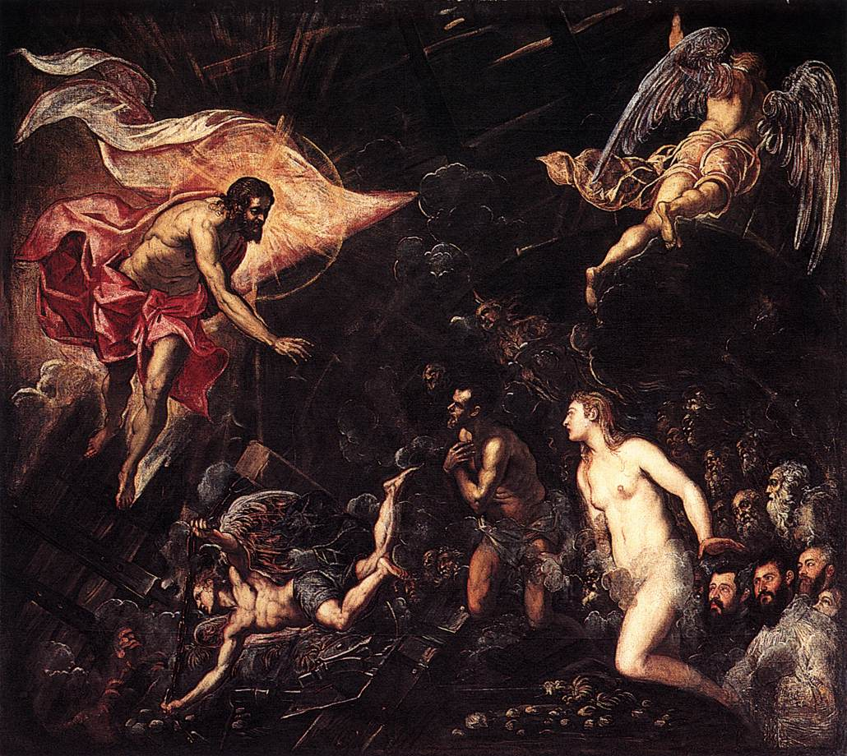

Jacobo Tintoretto, “The Descent into Hell”

HELL will be the opposite of heaven. In describing the Final Judgment, Jesus says: “Then he will say to those on his left, ‘Depart from me, you accursed, into the eternal fire prepared for the devil and his angels.” (Matt. 25:41). And in the Book of Revelation we read: “Then Death and Hades were thrown into the lake of fire. This is the second death, the lake of fire; and anyone whose name was not found in the Book of Life was thrown into the lake of fire” (Rev. 20:14-15). Some Scripture scholars and historians ascribe this “lake of fire” as resembling a great garbage heap outside the city walls of Jerusalem that burnt night and day filled with things that were no longer of any purpose.

Popular images of hell are usually of burning pits and of demons with pitchforks torturing the unfortunate souls who end up there for all eternity. Hell is indeed a reality. But the principal punishment isn’t physical torture: it is the spiritual anguish of being separated from GOD. Think of hell as the logical consequence for a person who willfully decided to separate himself or herself from GOD while alive. Once on such a journey, a person drifts further and further into a life of sin and away from the ONE who is the source of all life and happiness – and at death, that separation becomes complete and final.

But the reality is that when most of us die, we are neither perfect saints nor perfect sinners. We believe in God and desire God’s grace, yet we have areas of our life that need to be purged of selfishness and sin. Such souls need to undergo a period of purification in order to achieve the purity and holiness necessary to enter fully into the glory of God’s presence in heaven. This purification is also called a PURGATION and it occurs in PURGATORY. Souls in Purgatory are assured of entering into heaven once their period of purification is completed. This is a belief that is somewhat unique to the Catholic faith and not shared by other Christian groups. But it is a part of the truth of God revealed in Tradition, and it makes perfect sense if you think about it.

The Christian belief in Purgatory (most especially between Catholics and Orthodox Christians) is also found in Scripture. Our Catholic Catechism defines PURGATORY in these words: “All who die in God’s grace and friend ship, but still imperfectly purified, are indeed assured of their eternal salvation; but after death they undergo purification, so as to achieve the holiness necessary to enter the joy of heaven” (CCC 1030).

Note that the Church believes that Purgatory is not a permanent state, but rather a state of purification before entering eternal life with God in heaven.

Scripture teaches us that nothing unclean can enter heaven (see Rev. 21:27, as well as 1 Corinthians 3:13-15). Purgatory is a place that cleanses us of whatever impurity we have when we die, allowing us to enter into God’s presence without the stain of sin.

In conclusion I ask you to read and reflect on the last paragraphs on p. 160 of your textbook that remind us that, “Our Christian belief about the ‘LAST THINGS’ assures us that God [always] has the last word. Our end in this life is but the birth-day to an eternal life with the Lord. The doctrines of the resurrection of the body, judgment, and life everlasting teach that everything we do, or fail to do, has significance. If WE CHOOSE JESUS, who is the AMEN of God’s love for us, and stay close to him in this life, then we have the promise of Jesus:

“In truth I tell you, there is no one who has left house, brothers, sisters, mother, father, children or land for my sake, and for the sake of the gospel who will not receive a hundred times as much houses, brothers, sisters, mothers, children and land – and persecutions too – now in this present time and, in the world to come, eternal life,” (Mark 10:29-30)

